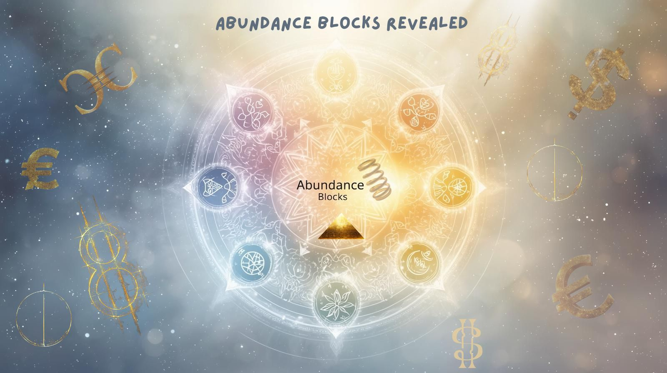

🌟 Free Mini Guide
‘Which Abundance Block Does Your Life Path Hold?’
Discover the subtle energy that keeps your flow stuck — and the key to setting it free.

💫 Welcome
Hey beautiful soul,
Abundance isn’t just about money — it’s about energy, ease, joy, and the flow that comes when you’re living in tune with your natural rhythm. Numerology is one of the simplest yet most magical tools to uncover where that flow gets tangled — and how to bring it back into balance.
Your Life Path Number is your personal blueprint — the song your soul came to sing. It shows both your greatest gifts and the challenges that test your growth. When energy gets stuck in those challenges, abundance can feel out of reach. But once you see the block, you can shift it — fast.
Use the chart below to find your Life Path’s abundance block, then try the affirmation and mini shift action to get your flow moving again.

🔮 Find Your Life Path Number
First add together the numbers of your day of birth until you have a single number, then your month, then your year of birth. Now add the three numbers together, reduce to a single digit unless you come across 11, 22, or 33 (which are Master Numbers and stay as they are).
Example:
12/03/1960 Day 12 (1+2) = 3 Month 3 Year 1 + 9 + 6 + 0 = 16, 1+6=7
Finally: 3+3+7 = 13 (1+3)=4
Life Path 4

🌿 Your Life Path, Your Abundance Block & Shift
1 – The Leader
Block: Fear of taking charge or doubting your worth.
Shift Phrase: ‘I trust my instincts and lead with confidence.’
Mini Shift: Do one thing solo today — make a choice, start a project, own your space. Leadership begins with self-trust.

2 – The Peacemaker
Block: Over-giving, people-pleasing, or blending in.
Shift Phrase: ‘I am part of the harmony, not lost in it.’
Mini Shift: Say one gentle no today. True peace includes your needs, too.

3 – The Creator
Block: Fear of being judged, silenced, or not taken seriously.
Shift Phrase: ‘My creativity is my superpower.’
Mini Shift: Express something playful or imperfect. Laughter and colour restore flow.

4 – The Builder
Block: Overwork, rigidity, or fear of failure.
Shift Phrase: ‘I am safe to build with ease.’
Mini Shift: Step away from structure for an hour — wander, doodle, or daydream. Flow fuels foundation.

5 The Freedom Seeker –
Block: Scattered focus, impulsiveness, or avoiding responsibility.
Shift Phrase: ‘Freedom flows through focused action.’
Mini Shift: Choose one thing to complete today — liberation loves follow-through.

6 – The Nurturer
Block: Carrying others’ burdens or guilt for self-care.
Shift Phrase: ‘My care begins with me.’
Mini Shift: Do one nourishing thing just for you — a rest, a bath, a boundary.

7 – The Seeker
Block: Isolation, mistrust, or overthinking.
Shift Phrase: ‘I trust the mystery and open to grace.’
Mini Shift: Step outside and breathe the sky — let nature remind you that you belong to everything.

8 – The Powerhouse
Block: Control, fear of loss, or feeling undeserving.
Shift Phrase: ‘Power and abundance flow through me with ease.’
Mini Shift: Release one ‘must’ — let something unfold without forcing the outcome.

9 – The Humanitarian
Block: Holding on to endings or carrying old pain.
Shift Phrase: ‘I let go, and my gifts flow forward.’
Mini Shift: Write or burn a release note — forgiveness clears the channel.

11 – The Illuminator
Block: Overwhelm, self-doubt, or fear of visibility.
Shift Phrase: ‘My light uplifts with ease.’
Mini Shift: Share one spark of wisdom — your light is medicine for others.

22 – The Master Builder
Block: Perfectionism or pressure to change the world overnight.
Shift Phrase: ‘I build with patience, trust, and soul.’
Mini Shift: Create something messy and magical — release the need for results.

33 – The Master Healer
Block: Over giving and forgetting your own heart.
Shift Phrase: ‘I heal by honouring my own joy.’
Mini Shift: Rest. Let your radiance recharge — healing begins in your own light.

✨ Closing Message
Abundance isn’t about chasing more — it’s about opening to what already wants to flow through you.
Now that you’ve uncovered your block, it’s time to shift it into momentum. Each small choice you make to honour your energy brings you closer to effortless flow, creativity, and joy.
If you loved this glimpse into your numbers, join me for Creative Codes: Numerology for Abundance & Flow — a heart-led course designed to help you discover your core numbers, clear the blocks, connect to your creative current, and step into the abundance that’s been waiting for you all along.
👉 Contact: Https://www.fourseasonsnumerology.com
Or email your enquiry to: shazenewman@fourseasonsnumerology.com

